Revenue Cloud Verification Catalog — Setup Manual
Oct 6, 2026 · @John
This manual builds the Verification Check catalog recommended in models/verification-catalog.recommendation.yaml in a Revenue Cloud org, by hand, through the Lightning UI. Every step was performed in m3ter-arm-260 on 6 October 2026 and every picture is from that build; one worked example (Document Check - Boost, plus the AE bundle) is shown screen by screen, and the remaining 31 products follow the same clicks with the values in the tables at the end.

Before you start
The build is 10 steps in a fixed order, because almost every record looks up one created before it. Three things decide the order and are easy to get wrong.
Count before you create. The org is pre-seeded. Before this build it already held 5 unit-of-measure classes, 12 units (USD among them, EUR not), 4 rate cards (all on the single Standard Price Book), 9 selling models (Evergreen Monthly is the one this catalog uses) and 45 attribute definitions. Nothing named Verification existed. Run the equivalent query for your org first; reuse what is there and only create what is missing.
Draft first, Active last. Five objects have a Draft → Active lifecycle and refuse to be created Active: Unit of Measure Class, Usage Resource, Product Usage Resource, Rate Card Entry, and (not used here) Product Usage Grant. Create them in Draft, finish everything that references them, then activate from the bottom of the chain up (Step 10). Activation is a one-way door: an Active rate card entry cannot take new attribute adjustments, and an Active record cannot be deleted without deactivating first.
Rate cards carry the price. The org's own pre-seeded Base Rate Card is the pattern: one Rate Card Entry per product per rate card with a flat Rate, a currency unit of measure as the rate unit, and a 0.00 price book entry so the product is quotable. Both Verification rate cards hang off the Standard Price Book, like every other rate card in the org.
The order:
- Units of measure (class → units → activate the class)
- Attribute IS-RETRY (picklist → values → definition)
- Classifications (two) and the attribute link
- Catalog and categories
- Product
- Selling model option, usage resource, product usage resource, category link
- Bundle product (same chain, different purpose)
- Rate cards and their price book links
- Price book entry and rate card entries
- Activate: usage resources → product usage resources → rate card entries
Every form below is reached the same way: open the object's list view in the Revenue Cloud app (App Launcher → the object name, or /lightning/o/<Object>/new in the address bar) and click New. The pictures show the form as it looks the moment before Save.
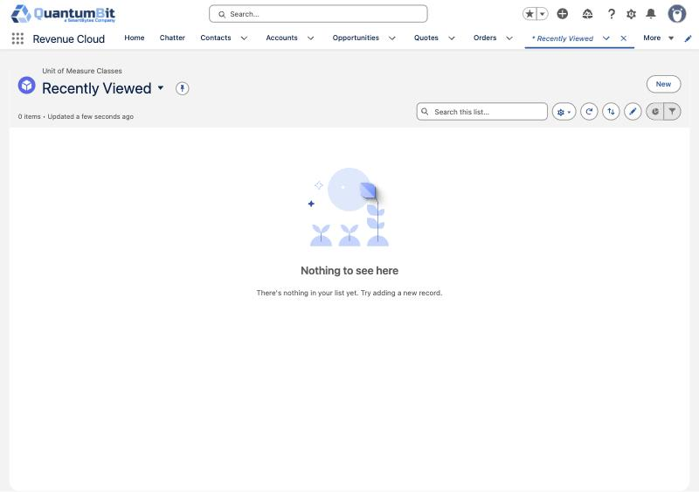

Step 1 — Units of measure
Three records: one class, two units in it, and a EUR unit in the existing Currency class. The class is created in Draft and activated after its units exist, because its default unit is one of them.

1a. Unit of Measure Class
Object: Unit of Measure Class → New.
Field | Value
Name | Verification Usage
Code | VERIFICATION-UOM-CLASS
Description | Units for identity verification usage (checks, blocks). From m3ter meters.
Status | Draft (see below)
Default Unit Of Measure | leave empty for now
Type | Usage
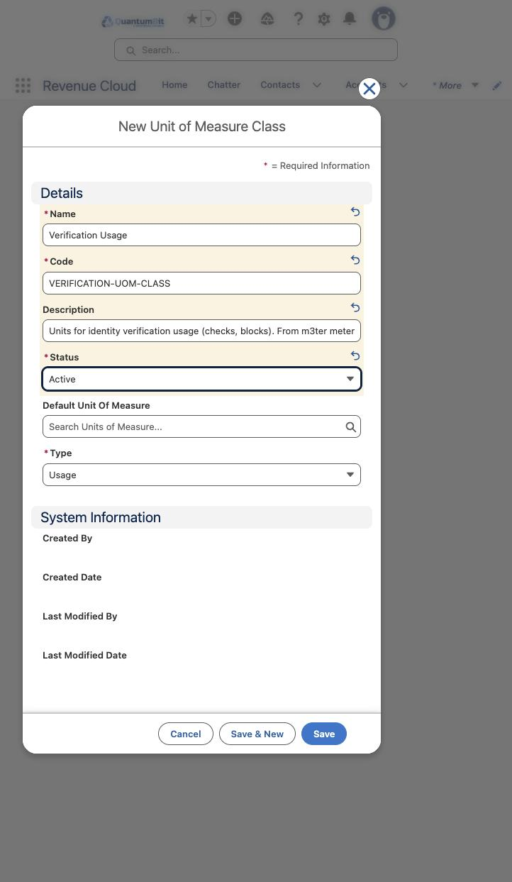
Saving with Status = Active is refused: "You can create the record when it's in Draft status only." This is the first of the lifecycle objects.
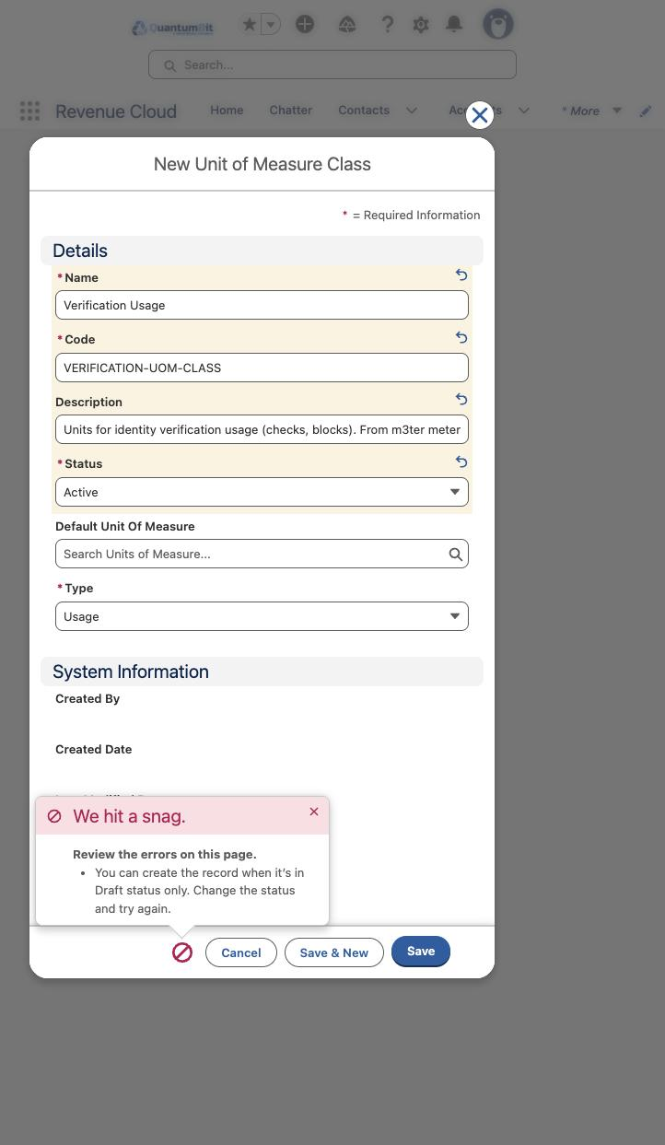
Set Status to Draft and save.
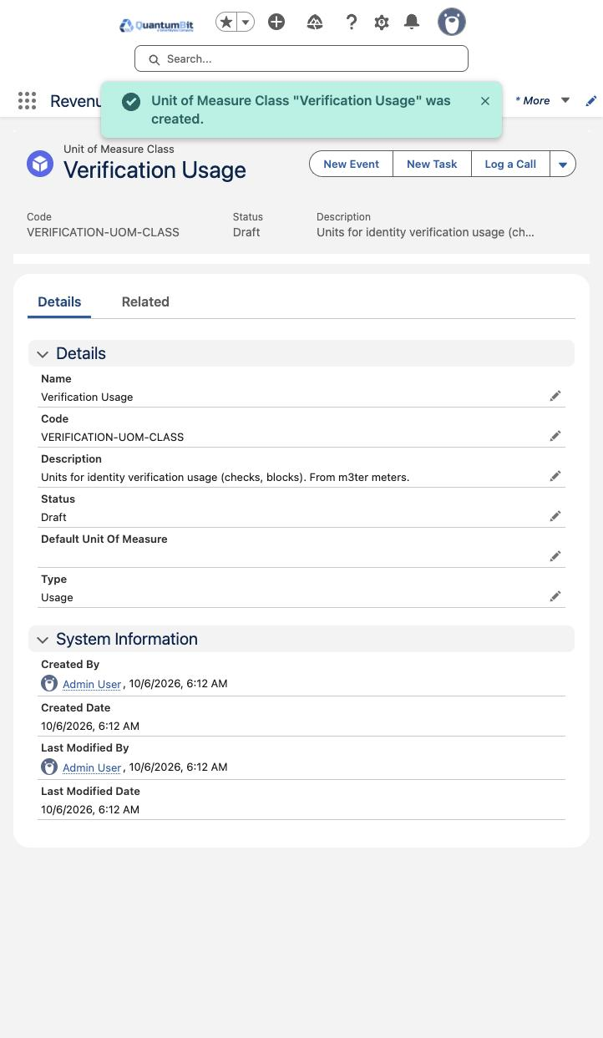

1b. Units of measure
Object: Unit of Measure → New. Units are not lifecycle objects; create them Active. Type offers only Custom in the UI (the pre-seeded Count/Cost/Data types are not selectable), which the rate card accepts.
Field | Check | Block | EUR
Name | Check | Block | EUR
Unit Code | CHECK | BLOCK | EUR
Conversion Factor | 1 | 1 | 1
Unit of Measure Class | Verification Usage | Verification Usage | Currency (existing)
Type | Custom | Custom | Custom
Status | Active | Active | Active
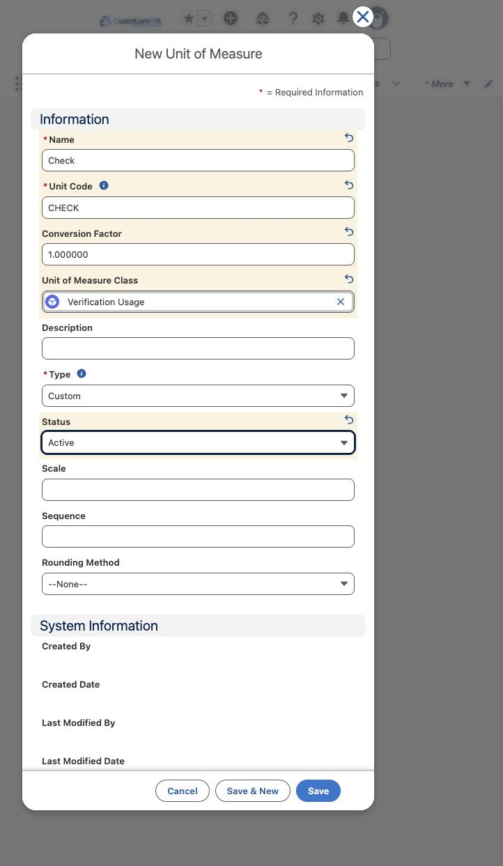
EUR goes under the existing Currency class, beside the pre-seeded USD unit; it is the rate unit for the EUR rate card entries in Step 9.
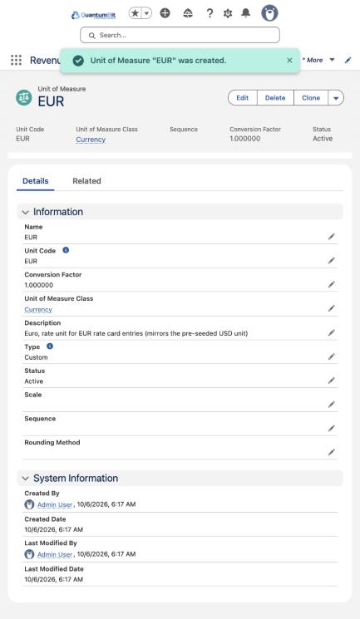

1c. Activate the class
Open Verification Usage → Edit. Set Default Unit Of Measure = Check and Status = Active, save.
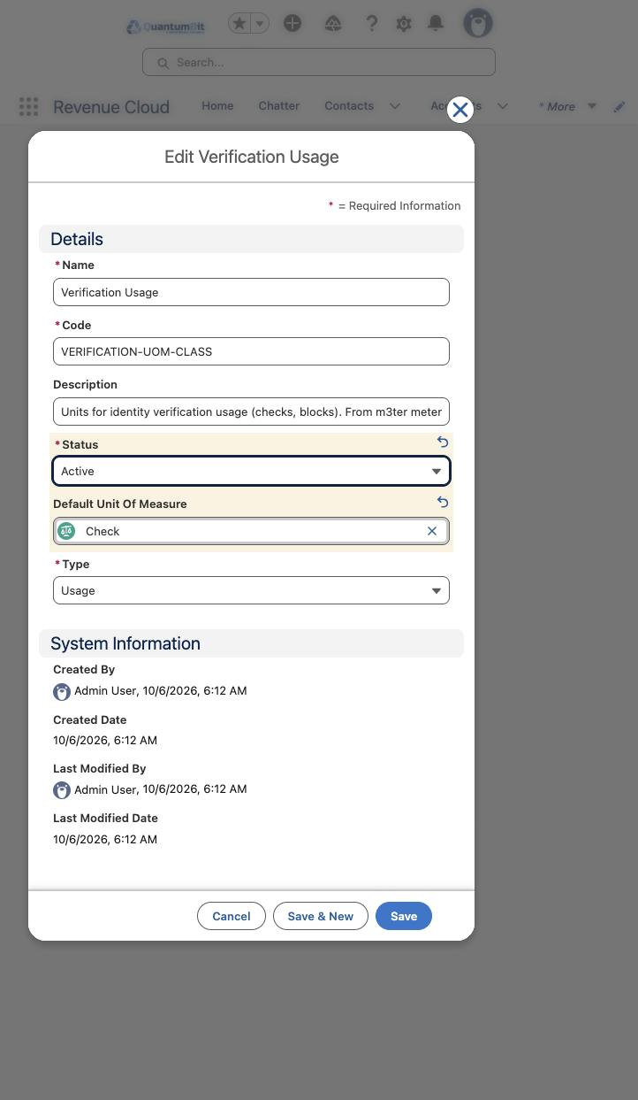

Step 2 — The IS-RETRY attribute
Three records, in this order: the picklist, its two values, then the attribute definition that points at the picklist. This is the same pattern the Claude catalog uses for Model Tier and Token Direction. No rate adjustment rule is created for it: both m3ter price lists charge retry and non-retry identically today, so the attribute exists for the day they diverge.

2a. Attribute Picklist
Object: Attribute Picklist → New. Data Type defaults to Boolean; change it to Text so the values are codes rather than true/false flags.
Field | Value
Name | Is Retry Values
Code | PL-VC-ISRETRY
Description | Allowed values for the is_retry usage dimension (m3ter WHAT field on the ETSI video document checks).
Data Type | Text
Status | Active
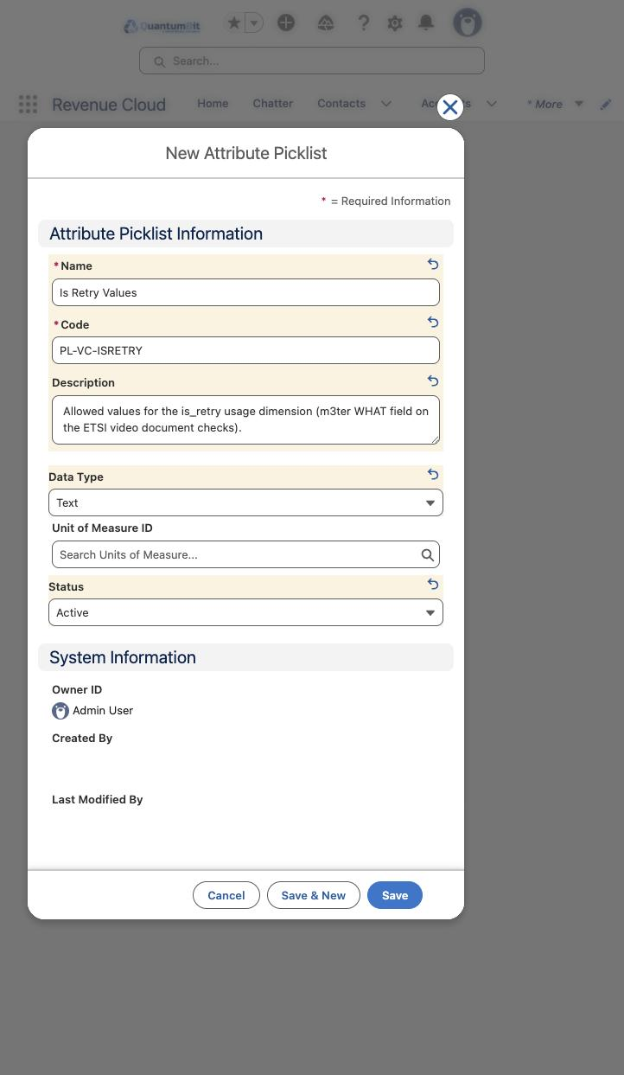

2b. Attribute Picklist Values
Object: Attribute Picklist Value → New, twice. The Code is what rating conditions will match on later; keep it uppercase.
Field | True | False
Picklist | Is Retry Values | Is Retry Values
Name | True | False
Code | TRUE | FALSE
Value | true | false
Sequence | 1 | 2
Status | Active | Active
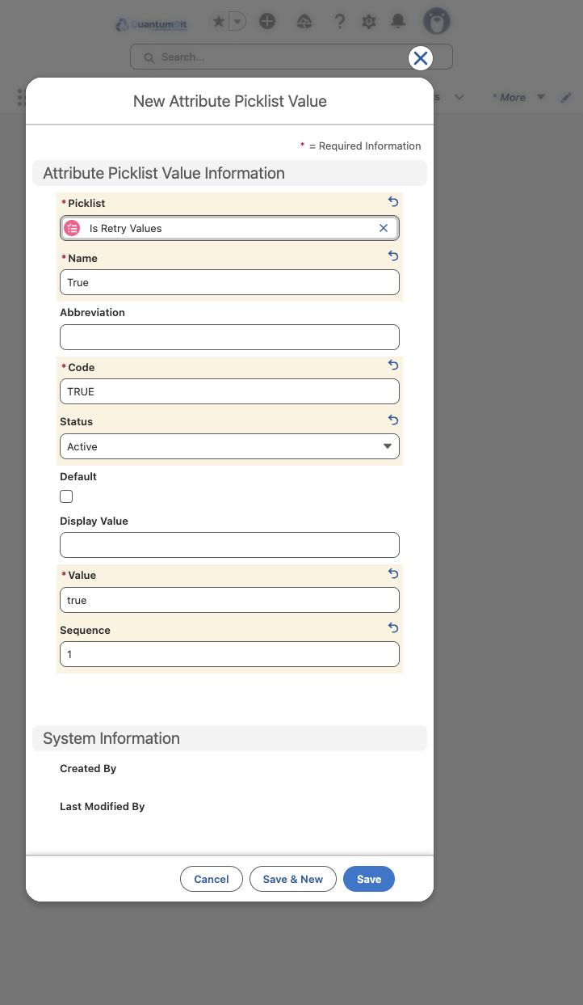

2c. Attribute Definition
Object: Attribute Definition → New. The Code field is at the bottom of the form, below Value Description; scroll inside the modal to reach it.
Field | Value
Name / Label | Is Retry
API Name | Is_Retry
Data Type | Picklist
Picklist | Is Retry Values
Active | ticked
Description | Whether a video document check was a retry. Mirrors the m3ter is_retry segment; priced identically today.
Code | ATTR-VC-ISRETRY
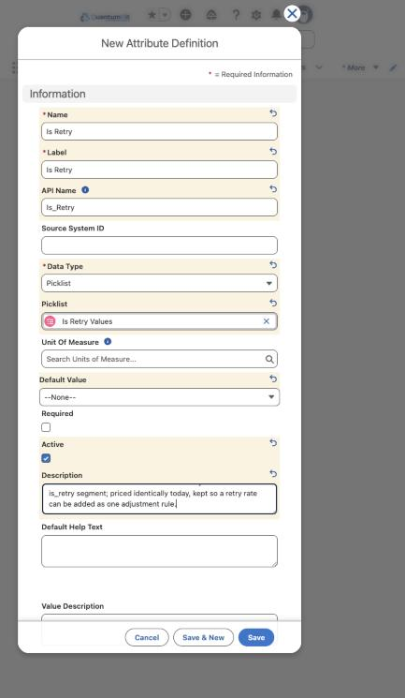
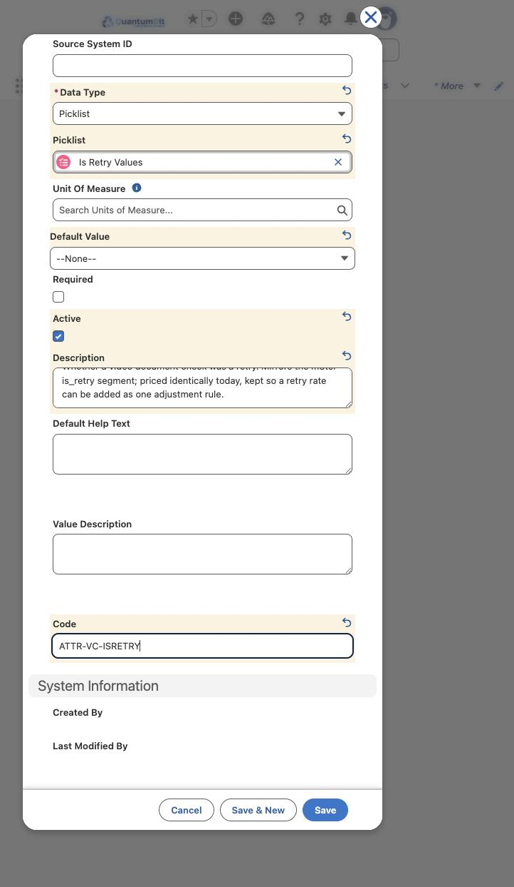

Step 3 — Product classifications and the attribute link
Two classifications: a plain one for the 31 ordinary products and a child of it for the two ETSI video products that carry IS-RETRY. The attribute is attached to the child only, so the other products never see it.

3a. Product Classification (two)
Object: Product Classification → New.
Field | Plain | Retry-aware
Product Classification Name | Verification Check | Verification Check (retry-aware)
Parent Product Classification | — | Verification Check
Code | PC-VERIFICATION-CHECK | PC-VERIFICATION-CHECK-RETRY
Status | Active | Active
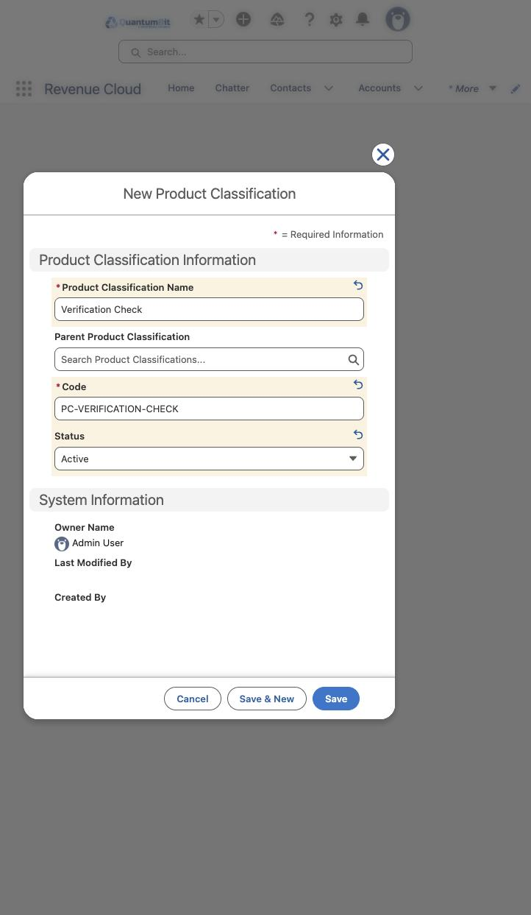
A record saved seconds earlier may not yet appear in a lookup's search results; type the parent's full name and wait, or search again.

3b. Product Classification Attribute
Object: Product Classification Attribute → New. Tick Is Price Impacting (rating will key on it) and Is Required under Runtime Settings. Note: the org saved this build's record with Is Required = false; re-check the box on the saved record if the quote should insist on a value.
Field | Value
Product Classification | Verification Check (retry-aware)
Attribute | Is Retry
Name | Verification Check (retry-aware) / Is Retry
Status | Active
Description | Retry flag for the two ETSI video document checks. Rating dimension from m3ter is_retry.
Is Price Impacting | ticked
Is Required | ticked
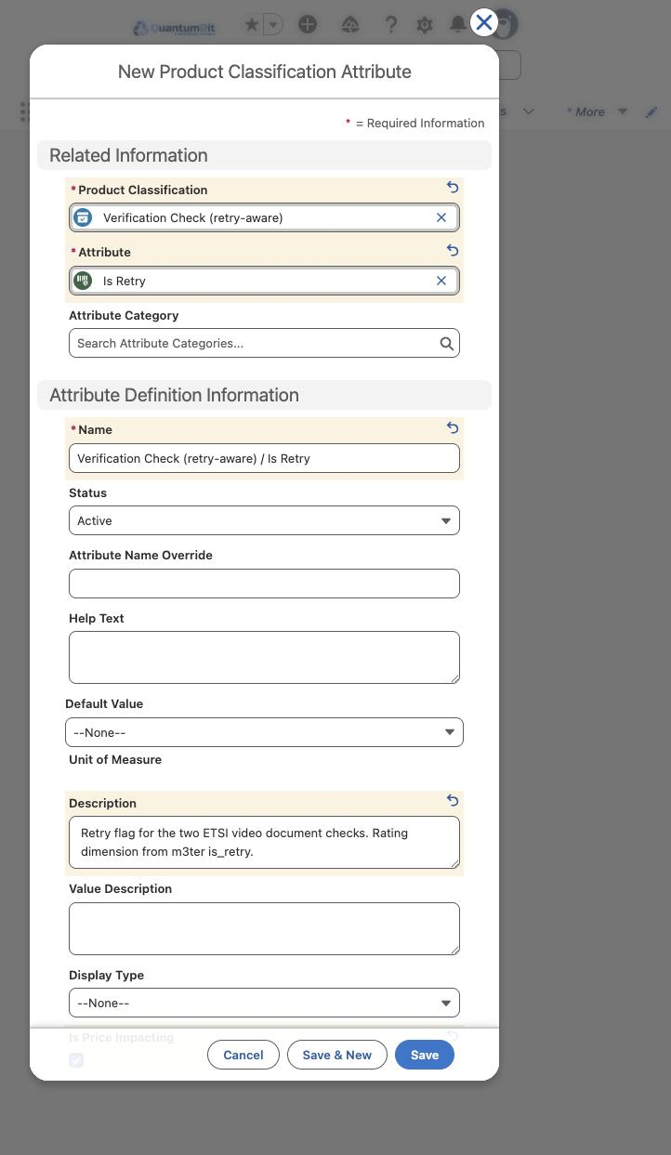
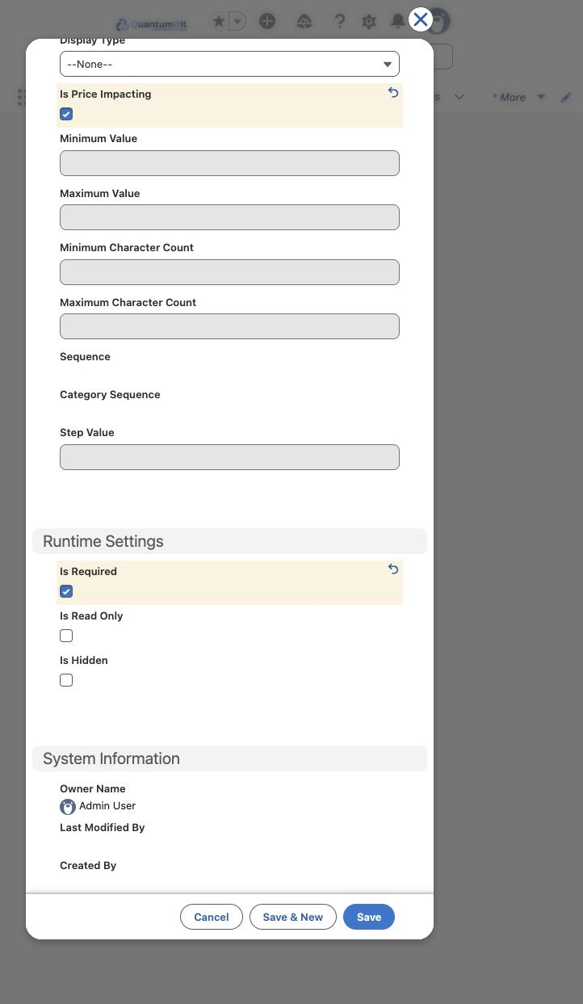

Step 4 — Catalog and categories
One catalog and six categories. Two were created in this build (the ones the worked examples need); the other four use the same form with the values in the table.

4a. Catalog
Object: Catalog → New. Catalog Type stays Sales; the dates stay empty.
Field | Value
Name | Verification Catalog
Description | Identity verification checks, rated per check from m3ter usage. 33 products, 2 bundles.
Code | CAT-VERIFICATION
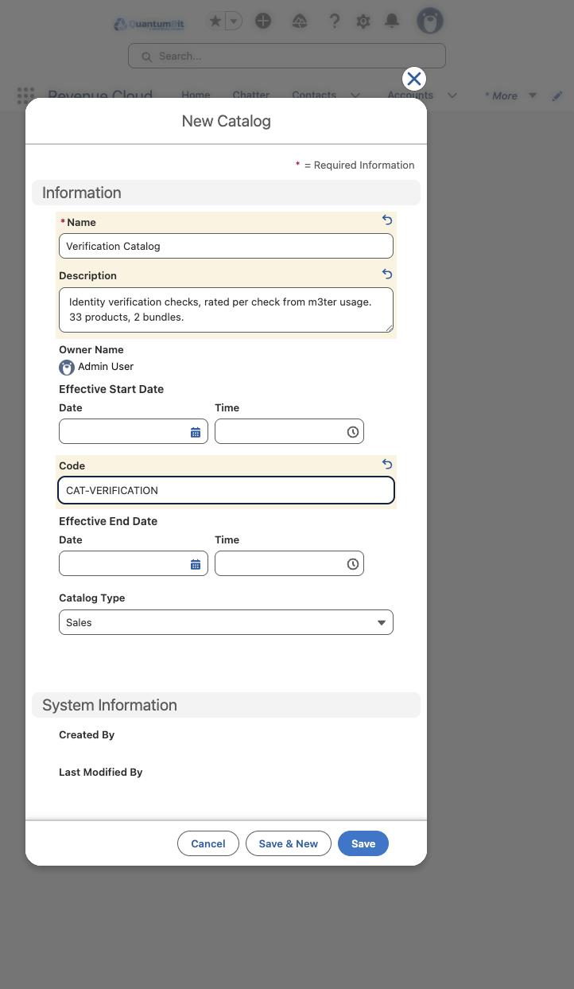

4b. Categories
Object: Category → New, once per row. Show In Menu stays ticked; no parent category.
Name | Code | Sort Order | Built on 6 Oct
Document Checks | CAT-DOCUMENT-CHECKS | 1 | yes
Biometrics | CAT-BIOMETRICS | 2 | no
Watchlist & Monitoring | CAT-WATCHLIST-MONITORING | 3 | no
Identity Data | CAT-IDENTITY-DATA | 4 | no
eID & Signatures | CAT-EID-SIGNATURES | 5 | no
Bundles | CAT-BUNDLES | 6 | yes
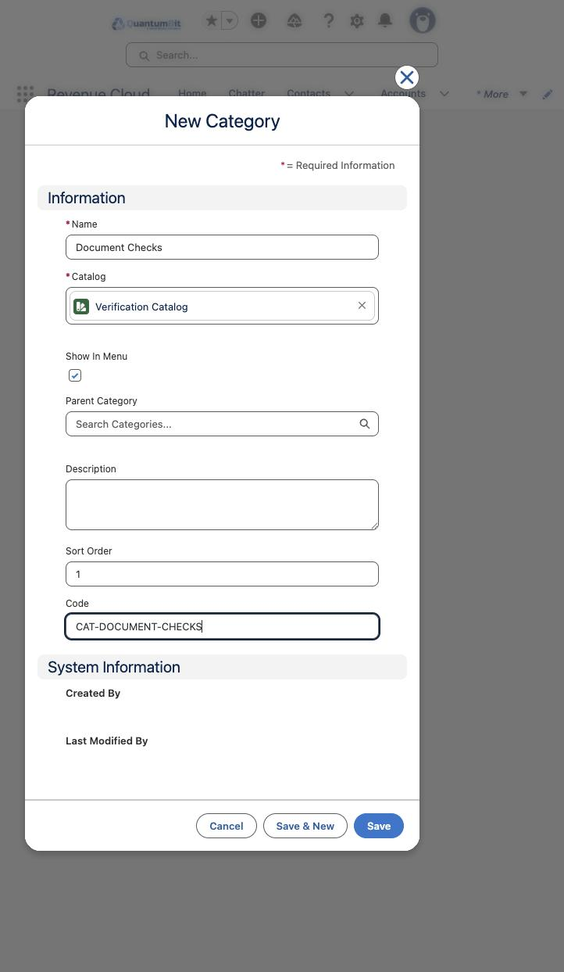

Step 5 — The product (worked example: Document Check - Boost)
The product comes before its usage resource, because the resource's Usage Definition Product lookup needs it. One m3ter meter = one product; the product code is the meter code, uppercased and hyphenated, prefixed VC-, so the two can be joined by eye.
Object: Product → New. The form has two halves; the Revenue Cloud section is below the fold.
Field | Value | Why
Product Name | Document Check - Boost | m3ter meter name
Product Code | VC-DOCUMENT-REPORT-STANDARD-HYBRID | VC- + meter code
Product Currency | USD - U.S. Dollar | default; price book entries carry their own currency
Unit of Measure | Check | from Step 1
Product Family | Services | nearest of the org's options
Active | ticked
Configure During Sale | Not Allowed | nothing to configure on a flat-rate check
Based On | Verification Check | Step 3 (the retry-aware one for the two ETSI video products)
Is Assetizable | ticked (default)
Usage Model Type | Pack | same as the Claude API usage product
Product Description | Hybrid (automated + analyst) identity document check. Rated per check from m3ter meter document_report_standard_hybrid.
[image: Product form, upper half]
[image: Product form, Revenue Cloud section]
After Save, the product page's Related List Quick Links show where the next step's records hang: Product Selling Model Option, Price Books, Categories.
[image: Saved product with related-list links]

Step 6 — Wiring the product
Four records per product, in this order. The resource and the junction are lifecycle objects and are saved in Draft.

6a. Product Selling Model Option
Object: Product Selling Model Option → New. Links the product to the Evergreen Monthly selling model (already in the org) and makes it the default. The Proration Policy fills itself.
Field | Value
Product | Document Check - Boost
Product Selling Model | Evergreen Monthly
Default | ticked
[image: Selling model option, filled]

6b. Usage Resource
Object: Usage Resource → New. Category offers Usage, Token or Currency; this is Usage.
Field | Value
Name | Document Check - Boost Checks
Code | RES-DOCUMENT-REPORT-STANDARD-HYBRID
Status | Draft
Description | Checks consumed on m3ter meter document_report_standard_hybrid (aggregation SUM of check_count).
Unit of Measure Class | Verification Usage
Default Unit Of Measure | Check
Category | Usage
Usage Definition Product | Document Check - Boost
[image: Usage resource, filled]

6c. Product Usage Resource
Object: Product Usage Resource → New. The junction between product and resource. Type the date and then click a label to close the picker; pressing Escape closes the whole form, and Tab does not leave the date field.
Field | Value
Status | Draft
Product | Document Check - Boost
Usage Resource | Document Check - Boost Checks
Effective Start Date | 1/1/2026, 12:00 AM
[image: Product usage resource, filled]

6d. Product Category Product
Object: Product Category Product → New. Puts the product in its category.
Field | Value
Category | Document Checks
Product | Document Check - Boost
Is Primary Category | ticked
[image: Category link, filled]

Step 7 — The bundle product
A bundle is the same four-record chain as Step 5–6 with a different meaning: its usage resource receives the result of m3ter's compound aggregation (max of the component counts), computed on the metering side and sent as one usage record. Revenue Cloud never sees the components; it rates the bundle resource at one price. The component products stay in the catalog and are rated at 0 on the contract, exactly as m3ter's plan-level overrides do today.
Values that differ from the worked example:
Record | Field | Value
Product | Product Name | Document Check Boost + Selfie Hybrid Bundle
Product | Product Code | VC-BUNDLE-AE
Product | Product Description | Bundle: max(Document Check - Boost, Facial Similarity - Selfie Hybrid) checks, billed at one bundle rate. m3ter CompoundAggregation AE; the metering side computes the max and sends it as one usage record.
Usage Resource | Name / Code | Bundle AE Checks / RES-BUNDLE-AE
Usage Resource | Description | max(document_report_standard_hybrid_count, facial_similarity_report_standard_count) per period, computed by m3ter CompoundAggregation AE.
Product Category Product | Category | Bundles
Everything else (classification, unit, selling model, Draft status, start date) is the same. The Finrate PLG bundle (VC-BUNDLE-PLG, EUR 1.82) follows identically once its formula is confirmed — the m3ter calculation names three components but the plan zeroes only one; see the open questions in the recommendation.

Step 8 — Rate cards and the price book link
The org only has the Standard Price Book, and every pre-seeded rate card hangs off it through a Price Book Rate Card record. So "Rate Card D (USD)" and "Rate Card B (EUR)" are two Rate Card records under the one price book, not two price books. That settles decision D1 in the YAML. The pre-seeded cards also use Type Base (the YAML says Attribute); we followed the org.

8a. Rate Card — once per currency
Object: Rate Cards → New.
Field | USD card | EUR card
Name | Verification Rate Card D (USD) | Verification Rate Card B (EUR)
Type | Base | Base
Rate Unit Of Measure | USD | EUR (built in Step 1)
Default Unit Of Measure | Check | Check
Negotiable | ✓ | ✓
Effective From | 9/14/2025 12:00 AM | 1/27/2025 12:00 AM
Status | Active | Active
[image: Rate Card form, filled for the USD card]
Rate cards are not Draft-only, so Active on create is fine. Saved as 1CIWs0000006kZdOAI (USD) and 1CIWs0000006kbFOAQ (EUR).

8b. Price Book Rate Card — once per rate card
Object: Price Book Rate Cards → New (or from the rate card's related list, which pre-fills the Rate Card lookup).
Field | Value
Rate Card | the card from 8a
Price Book | Standard Price Book
Effective From | same date as the rate card
Status | Active
[image: Price Book Rate Card linking the USD card to the Standard Price Book]
The Name auto-numbers (PRC-00000009 USD, PRC-00000010 EUR). Both links point at the same price book; which card a quote rates against is a quote-time choice, not a catalog one.

Step 9 — Price book entry and rate card entries
Two kinds of price record per product. The Price Book Entry puts the product in the price book at 0.00 so it can be quoted at all; the Rate Card Entry carries the real per-check rate. One rate card entry per product per currency card.

9a. Price Book Entry — once per product
Object: Price Book Entries → New (easiest from the product's Price Books related list).
Field | Value
Product | Document Check - Boost
Product Selling Model | Evergreen Monthly
Price Book | Standard Price Book
List Price | 0
Active | ✓
[image: Price Book Entry at 0.00]
Saved as 01uWs000007RGkbIAG. Only the USD entry for the worked product was built; the price book entry is currency-agnostic in a single-currency price book, so one per product is all the catalog needs. (The bundle's entry was not built — same form, bundle product.)

9b. Rate Card Entry — once per product per rate card
Object: Rate Card Entries → New. Status must be Draft on create. The Effective From date-time field pre-fills 12:00 PM — clear it fully and retype (see landmines).
Field | USD | EUR | Bundle (USD)
Rate Card | Verification Rate Card D (USD) | Verification Rate Card B (EUR) | Verification Rate Card D (USD)
Usage Resource | Document Check - Boost Checks | Document Check - Boost Checks | Bundle AE Checks
Product | Document Check - Boost | Document Check - Boost | Document Check Boost + Selfie Hybrid Bundle
Product Selling Model | Evergreen Monthly | Evergreen Monthly | Evergreen Monthly
Status | Draft | Draft | Draft
Rate Unit Of Measure | USD | EUR | USD
Rate | 1.59 | 2.28 | 1.54
Negotiable | ✓ | ✓ | ✓
Effective From | 9/14/2025 12:00 AM | 1/27/2025 12:00 AM | 9/14/2025 12:00 AM
[image: Rate Card Entry form, filled for the USD rate]
Saved as 1CJWs0000007Po5OAE (1.59 USD), 1CJWs0000007PphOAE (2.28 EUR) and 1CJWs0000007PrJOAU (1.54 USD bundle). The Rate field is the flat per-unit price: no tiers, no bands, which is all this catalog needs.

Step 10 — Activation, in dependency order
Everything saved as Draft now gets switched on. The order matters: a child refuses to activate while its parent is Draft, so work top-down.
- Unit of Measure Class — done in Step 1c.
- Usage Resource — open the resource → Edit → Status Active → Save. Do this for both resources (product and bundle).
- Product Usage Resource — same edit, both records.
- Rate Card Entry — same edit, all three entries.
[image: Usage Resource edit: Status set to Active]
[image: Rate Card Entry edit: Status set to Active]
After the last save, this query in the Developer Console should return only Active rows (it did):
SELECT Id, Name, Status FROM UsageResource WHERE Name LIKE '%Boost%' OR Name LIKE 'Bundle%'
SELECT Id, Status FROM ProductUsageResource WHERE UsageResourceId IN ('1BRWs0000006MttOAE','1BRWs0000006MvVOAU')
SELECT Id, Rate, Status FROM RateCardEntry WHERE RateCardId IN ('1CIWs0000006kZdOAI','1CIWs0000006kbFOAQ')
We did not test editing an Active entry back to Draft; Salesforce's documented pattern is to end-date an entry and add a new one rather than change a live rate. Get the Rate right before you flip it.

The other 31 products: values for every record
Every product in the catalog is the same six records as Step 5, 6 and 9: Product, Product Selling Model Option, Usage Resource, Product Usage Resource, Product Category Product, Price Book Entry, plus one Rate Card Entry per currency. Only the names, codes, category and rates change. The table below is the whole catalog, generated from the YAML; rows 1 and 34 are the worked examples already in the org.
Derived values, the same for every row:
- Usage Resource Name = product name + " Checks"; Code = the Resource code column; Category Usage; Unit = the Unit column.
- Product Usage Model Type Pack, Selling Model Option = Evergreen Monthly, Classification = Verification Check (product 6 and 7 additionally get the Is Retry classification from Step 3).
- Price Book Entry = Standard Price Book, 0.
- Rate Card Entry = Status Draft, Negotiable, Rate = USD column on the USD card, EUR column on the EUR card; Effective From 9/14/2025 (USD) or 1/27/2025 (EUR).
- Products with a false … / true … rate carry the Is Retry attribute; both values are the same price today, so one rate card entry at that price with no attribute adjustment is all that is needed (decision D2).
- Rates of 0.00 are deliberate: free add-ons stay in the catalog so their usage is visible (decision D7).
Categories to create in Step 4b, one each: Document Checks, Biometrics, Watchlist & Monitoring, Identity Data, eID & Signatures, Bundles (Bundles was built; the other five follow the same form).
# | Product name | Product code | Resource code | Unit | Category | USD | EUR | m3ter meter
1 | Document Check - Boost | VC-DOCUMENT-REPORT-STANDARD-HYBRID | RES-DOCUMENT-REPORT-STANDARD-HYBRID | Check | Document Checks | 1.59 | 2.28 | document_report_standard_hybrid
2 | Document Check - Flash | VC-DOCUMENT-REPORT-STANDARD-AUTO | RES-DOCUMENT-REPORT-STANDARD-AUTO | Check | Document Checks | 0.54 | 0.65 | document_report_standard_auto
3 | Document Check - Sherlock | VC-DOCUMENT-REPORT-STANDARD-MANUAL | RES-DOCUMENT-REPORT-STANDARD-MANUAL | Check | Document Checks | 2.78 | 3.02 | document_report_standard_manual
4 | Document Check - Driver Verification | VC-DOCUMENT-REPORT-DRIVER-VERIFICATION | RES-DOCUMENT-REPORT-DRIVER-VERIFICATION | Check | Document Checks | 1.59 | 2.28 | document_report_driver_verification
5 | Document Check Video - Boost | VC-DOCUMENT-REPORT-VIDEO | RES-DOCUMENT-REPORT-VIDEO | Check | Document Checks | 2.05 | 2.28 | document_report_video
6 | Document Check Video - Boost - ETSI Certified IDV | VC-DOCUMENT-REPORT-VIDEO-ETSI-CERTIFIED-IDV | RES-DOCUMENT-REPORT-VIDEO-ETSI-CERTIFIED-IDV | Check | Document Checks | false 3.72 / true 3.72 | false 3.57 / true 3.57 | document_report_video_ETSI_Certified_IDV
7 | Document Check Video - ETSI Certified IDV with QES and OTP | VC-DOCUMENT-REPORT-VIDEO-ETSI-CERTIFIED-IDV-WITH-QES-AND-OTP | RES-DOCUMENT-REPORT-VIDEO-ETSI-CERTIFIED-IDV-WITH-QES-AND-OTP | Check | Document Checks | false 4.03 / true 4.03 | false 3.87 / true 3.87 | document_report_video_ETSI_Certified_IDV_with_QES_and_OTP
8 | OCR Autofill | VC-AUTOFILL | RES-AUTOFILL | Check | Document Checks | 0.00 | 0.00 | autofill
9 | Facial Similarity Check - Selfie Hybrid | VC-FACIAL-SIMILARITY-REPORT-STANDARD | RES-FACIAL-SIMILARITY-REPORT-STANDARD | Check | Biometrics | 0.95 | 1.08 | facial_similarity_report_standard
10 | Facial Similarity Check - Selfie Auto | VC-FACIAL-SIMILARITY-REPORT-PHOTO-FULLY-AUTO | RES-FACIAL-SIMILARITY-REPORT-PHOTO-FULLY-AUTO | Check | Biometrics | 0.77 | 0.88 | facial_similarity_report_photo_fully_auto
11 | Facial Similarity Check - Video | VC-FACIAL-SIMILARITY-REPORT-VIDEO | RES-FACIAL-SIMILARITY-REPORT-VIDEO | Check | Biometrics | 1.36 | 1.53 | facial_similarity_report_video
12 | Facial Similarity Check - Motion | VC-FACIAL-SIMILARITY-REPORT-MOTION | RES-FACIAL-SIMILARITY-REPORT-MOTION | Check | Biometrics | 1.21 | 1.36 | facial_similarity_report_motion
13 | Authentication: Motion | VC-MOTION-AUTHENTICATION | RES-MOTION-AUTHENTICATION | Check | Biometrics | 0.40 | 0.38 | motion_authentication
14 | Facial Similarity Check Upgrade - Known Faces | VC-KNOWN-FACES-REPORT-STANDARD | RES-KNOWN-FACES-REPORT-STANDARD | Check | Biometrics | 0.00 | 0.00 | known_faces_report_standard
15 | Repeat Attempts | VC-REPEAT-ATTEMPTS-REPORT-STANDARD | RES-REPEAT-ATTEMPTS-REPORT-STANDARD | Check | Biometrics | 0.00 | 0.00 | repeat_attempts_report_standard
16 | Device Intelligence - Standard | VC-APPLICANT-FRAUD-REPORT-STANDARD | RES-APPLICANT-FRAUD-REPORT-STANDARD | Check | Biometrics | 0.00 | 0.00 | applicant_fraud_report_standard
17 | Watchlist - AML | VC-WATCHLIST-REPORT-AML | RES-WATCHLIST-REPORT-AML | Check | Watchlist & Monitoring | 0.49 | 0.56 | watchlist_report_aml
18 | Watchlist - Enhanced (KYC) | VC-WATCHLIST-REPORT-KYC | RES-WATCHLIST-REPORT-KYC | Check | Watchlist & Monitoring | 0.49 | 0.56 | watchlist_report_kyc
19 | Watchlist - Standard (Full) | VC-WATCHLIST-REPORT-FULL | RES-WATCHLIST-REPORT-FULL | Check | Watchlist & Monitoring | 0.42 | 0.47 | watchlist_report_full
20 | Ongoing Monitoring for Watchlist AML Top Up | VC-ONGOING-MONITORING-AML-TOP-UP | RES-ONGOING-MONITORING-AML-TOP-UP | Block | Watchlist & Monitoring | 0.00 | 0.00 | ongoing_monitoring_aml_top_up
21 | ID Record | VC-IDENTITY-REPORT-STANDARD | RES-IDENTITY-REPORT-STANDARD | Check | Identity Data | 1.38 | 1.72 | identity_report_standard
22 | SSN Check | VC-SSN-REPORT-STANDARD | RES-SSN-REPORT-STANDARD | Check | Identity Data | 1.00 | 0.96 | ssn_report_standard
23 | AAMVA Check | VC-US-DRIVING-LICENCE-REPORT-STANDARD | RES-US-DRIVING-LICENCE-REPORT-STANDARD | Check | Identity Data | 1.98 | 1.90 | us_driving_licence_report_standard
24 | India Tax ID | VC-INDIA-PAN-REPORT-STANDARD | RES-INDIA-PAN-REPORT-STANDARD | Check | Identity Data | 0.25 | 0.24 | india_pan_report_standard
25 | Proof of Address | VC-PROOF-OF-ADDRESS-REPORT-STANDARD | RES-PROOF-OF-ADDRESS-REPORT-STANDARD | Check | Identity Data | 2.36 | 2.28 | proof_of_address_report_standard
26 | Right to Work (UK Only) | VC-RIGHT-TO-WORK-REPORT-STANDARD | RES-RIGHT-TO-WORK-REPORT-STANDARD | Check | Identity Data | 6.53 | 6.02 | right_to_work_report_standard
27 | Mastercard Identity - Account Opening (AMER) | VC-MASTERCARD-IDENTITY-ACCOUNT-OPENING-AMER | RES-MASTERCARD-IDENTITY-ACCOUNT-OPENING-AMER | Check | Identity Data | 0.30 | 0.29 | mastercard_identity_account_opening_amer
28 | Mastercard Identity - Account Opening (EMEA) | VC-MASTERCARD-IDENTITY-ACCOUNT-OPENING-EMEA | RES-MASTERCARD-IDENTITY-ACCOUNT-OPENING-EMEA | Check | Identity Data | 0.30 | 0.29 | mastercard_identity_account_opening_emea
29 | Mastercard Identity - Account Opening (ROW) | VC-MASTERCARD-IDENTITY-ACCOUNT-OPENING-ROW | RES-MASTERCARD-IDENTITY-ACCOUNT-OPENING-ROW | Check | Identity Data | 0.30 | 0.29 | mastercard_identity_account_opening_row
30 | eID, Italy - SPID Basic | VC-EID-SPID-BASIC | RES-EID-SPID-BASIC | Check | eID & Signatures | 5.97 | 5.73 | eid_spid_basic
31 | eID, Italy - SPID Full | VC-EID-SPID-FULL | RES-EID-SPID-FULL | Check | eID & Signatures | 10.29 | 9.88 | eid_spid_full
32 | eID, UK eVisa Verification | VC-UK-EVISA-VERIFICATION | RES-UK-EVISA-VERIFICATION | Check | eID & Signatures | 1.59 | 2.28 | uk_evisa_verification
33 | Signhost (Advanced Electronic Signature) | VC-ADVANCED-ELECTRONIC-SIGNATURE | RES-ADVANCED-ELECTRONIC-SIGNATURE | Check | eID & Signatures | 1.33 | 1.28 | advanced_electronic_signature
34 | Document Check - Boost PLG & Facial Similarity Check - Selfie Hybrid | VC-BUNDLE-AE | RES-BUNDLE-AE | Check | Bundles | 1.54 | — | compound AE
35 | Document Check - Boost PLG & Motion | VC-BUNDLE-PLG | RES-BUNDLE-PLG | Check | Bundles | — | 1.82 | compound PLG
Bundle 35 (VC-BUNDLE-PLG, EUR 1.82) has an open anomaly: the m3ter formula names three components (Document Check - Boost, Motion, Watchlist - AML) but the Finrate plan only zeroes two of them, so Watchlist - AML may be double-charged today. Confirm with the m3ter owner before building it. The older EUR price versions (2022, 2023, pre-2025) are listed in the YAML under history_not_loaded and are not built.

What the org taught us: lessons and landmines
Everything below was hit during this build, not read in documentation. Each one changes either the YAML or the way rc-config should insert records.
Draft-only on create: five objects, not four. Unit of Measure Class joins Usage Resource, Product Usage Resource, Rate Card Entry and Product Usage Grant. Saving a new class as Active fails with "You can create the record when it's in Draft status only". rc-config's create_status override must cover UnitOfMeasureClass too, and the activation pass has to run after the units exist, because the class wants a Default Unit of Measure before it will go Active.
Unit of Measure Type is Custom-only in the UI. The picklist shows one selectable value. The YAML and the JSON config can stop pretending there is a choice.
EUR had to be created. UOM_USD existed (lookup-only in the Claude config); EUR did not. It lives in the pre-seeded Currency class (Type Currency) beside USD, as a Unit of Measure of Type Custom (USD's Type is Cost, which the UI did not offer), and it was accepted as the Rate Unit Of Measure on the EUR rate card and its entries. Whether rating treats a Custom-type currency unit exactly like USD's Cost type was not tested. The YAML's rate_units[EUR].verify_in_org question is answered.
Rate cards are Type Base and hang off the Standard Price Book. Every pre-seeded rate card in the org follows one pattern: Type Base, Rate Unit = a currency unit, Default Unit = the resource unit, Negotiable, linked to the Standard Price Book through Price Book Rate Card. Two currencies are two rate cards, one price book. The YAML's rate_card.type: Attribute is wrong for this org.
Usage Resource Category is Usage / Token / Currency. The YAML's category: Verification does not exist as a value. Use Usage.
Product Classification Attr "Is Required" did not stick. Ticked on the form, saved as false (SOQL-verified). Not re-tested; if it matters for quoting, set it by API and check.
Effective From is a date-time and the time half pre-fills 12:00 PM. Typing a date alone gives you noon. Clear the time, type 12:00 AM. Via the API this is a UTC datetime, so a date-only value from the YAML needs an explicit midnight in the org's timezone or you get an off-by-one day.
Lookups don't find a record by its full name immediately after creation. Searching "retry-aware" for a classification saved seconds earlier returned nothing; a shorter prefix found it. Index lag. The API has no such problem.
UI handling, for whoever repeats this by hand:
- Escape closes the whole modal, not just the date picker, and discards the form. Click a field label to dismiss a picker instead.
- Tab does not leave the date field; click the next field.
- Lookup "New" from inside a form (e.g. a new category from the Product Category Product form) works but loses the parent form's state in some objects. Create parents first, always.
- Pre-seeded records exist in this org (Claude catalog, Base rate cards). Count before you create; the Developer Console query editor is the fastest way (the REST API with a UI session cookie returns INVALID_SESSION_ID, so SOQL-in-console it is).

Records created in m3ter-arm-260
All of these exist in the org as of 6 October 2026, and every one with a Status is Active (SOQL-verified after Step 10). Leave them or delete them in reverse order of this list.
Object | Name | Id
Unit of Measure Class | Verification Usage | 1BQWs0000006wfdOAA
Unit of Measure | Check | 0hEWs0000018yEXMAY
Unit of Measure | Block | (in the class)
Unit of Measure | EUR | 0hEWs0000018yHlMAI
Attribute Picklist | Is Retry values | 0v5Ws0000012tflIAA
Attribute Definition | Is Retry | 0tjWs000001GtzFIAS
Product Classification | Verification Check, retry-aware | 11BWs00000cPgB3MAK
Product Classification Attr | Is Retry on the classification | 11CWs00001rSTRRMA4
Catalog | Verification Checks | 0ZSWs000001B5OnOAK
Category | Bundles | 0ZGWs000001cwDhOAI
Product | Document Check - Boost | 01tWs00000H8LDZIA3
Product | Document Check Boost + Selfie Hybrid Bundle | 01tWs00000H8LtVIAV
Product Selling Model Option | (both products, Evergreen Monthly) | 0iOWs000000bADJMA2, 0iOWs000000bAEvMAM
Usage Resource | Document Check - Boost Checks | 1BRWs0000006MttOAE
Usage Resource | Bundle AE Checks | 1BRWs0000006MvVOAU
Product Usage Resource | (both) | 1TrWs000000Cj2zKAC, 1TrWs000000Cj4bKAC
Product Category Product | (both) | 0ZRWs000001JfN3OAK, 0ZRWs000001JfOfOAK
Rate Card | Verification Rate Card D (USD) | 1CIWs0000006kZdOAI
Rate Card | Verification Rate Card B (EUR) | 1CIWs0000006kbFOAQ
Price Book Rate Card | PRC-00000009, PRC-00000010 | 1FnWs0000005gzVKAQ (EUR)
Price Book Entry | Document Check - Boost, 0.00 | 01uWs000007RGkbIAG
Rate Card Entry | Boost 1.59 USD | 1CJWs0000007Po5OAE
Rate Card Entry | Boost 2.28 EUR | 1CJWs0000007PphOAE
Rate Card Entry | Bundle 1.54 USD | 1CJWs0000007PrJOAU
Not built: the bundle's Price Book Entry, the five other categories, products 2–33 and bundle 35, and any rate card entry for them.

Sources
- models/verification-catalog.recommendation.yaml — the recommended catalog, generated from the two m3ter account exports (State of Delaware, USD; Finrate AG, EUR).
- models/m3ter-to-revenue-cloud.md — the mapping rationale and decisions D1–D7 referred to above.
- models/claude-catalog-data-model.html — the 25-object Revenue Cloud data model the YAML sits one level above.
- m3ter-arm-260 (Lightning UI and Developer Console), 6 October 2026 — every screenshot and every Id.

